# StarCraft 2 ladder help file

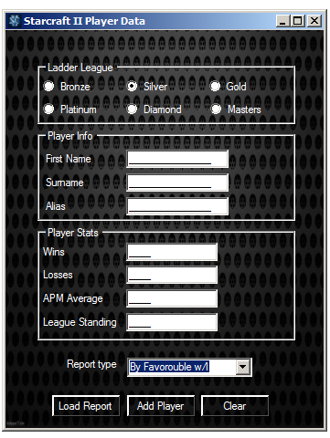

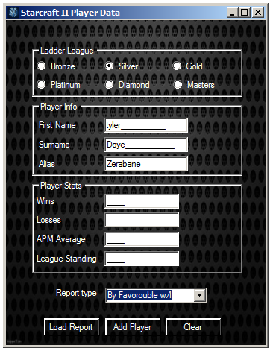This is the only screen you will interact with, first off start by picking a ladder league, only 1 league can be selected

next the you must insert your personal

information first name, surname and alias

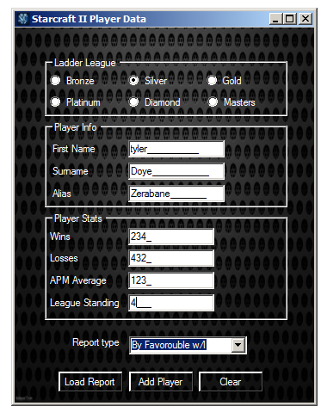 Next you must enter your game stats wins, losses, apm and league standing then click add player to add them to the file



If you wish to clear all the data press the clear buttonand the file will clear

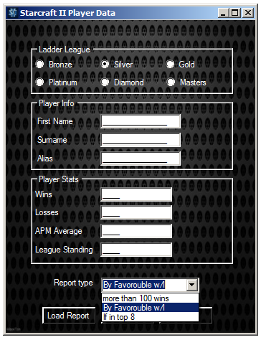You can select a report to show you other players that have stats fitting certain parameters which you may select on the Combobox

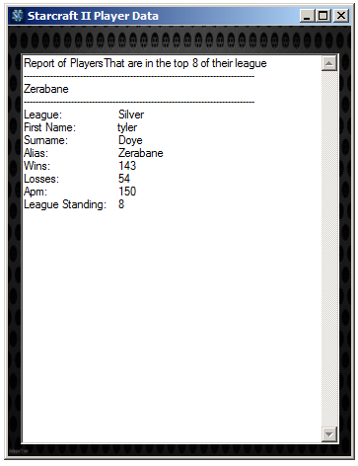And clicking load report

This page will show (right) it contains the user

Details that match the report you selected